ANDERIO FREDRICK TOUSSAINT 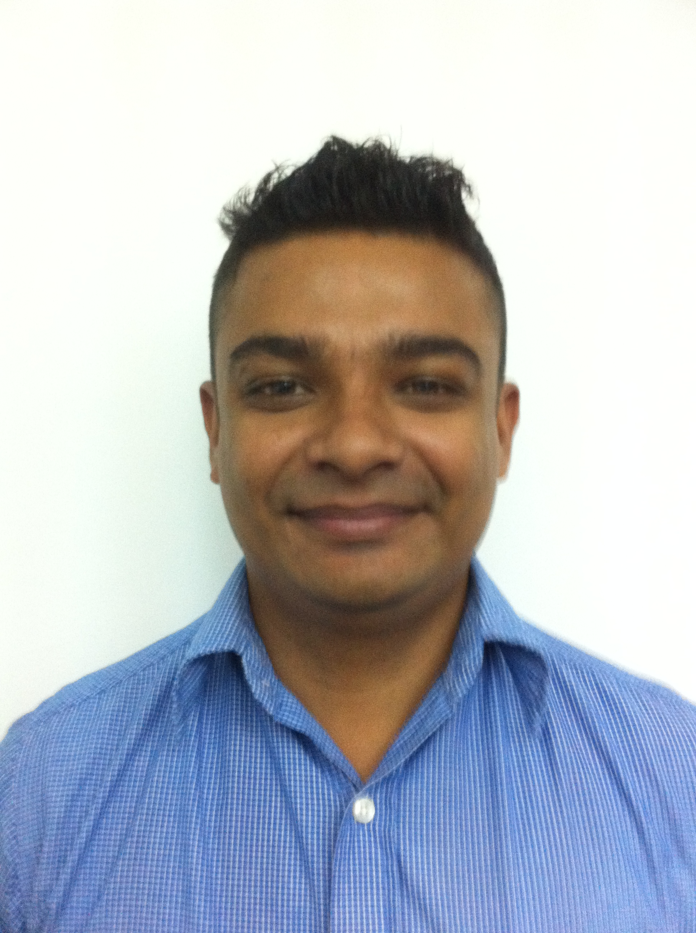
168 / 1B, Stanley Thilakarathna Mawatha,
Nugegoda. Sri Lanka
Mobile: +94 777 334105
Email: anderio21@gmail.com

Areas of expertise
- Team Leadership / Motivation
- Business Analysis
- CRM
- Staff Supervision / Development
- New Promotions
- Problem solving
- Quality Assurance

Passed the G.C.E. Ordinary Level Examination – 1999 as follows.

- English Language Distinction
- Sinhala Language Credit Pass
- Social Studies Credit Pass
- Science I Credit Pass
- Science II Credit Pass
- Mathematics I Credit Pass
- Mathematics II Simple Pass
- Religion Simple Pass

Professional experience and significant achievements

Currently Working at Mr. Cricket as a Retail Manager (June 2014 to up to date)
- Handle walk in clients.
- Handle daily sales and cash flow.
- Take the stock when required.
- Order the required good to the shop.
- And advice about the goods and promote new arrivals.
- Send quotation when client request.

Mediawize - Senior Client Serving Executive (January 2013 to up to May 2014)
My responsibilities include:
- Look into all the clients needs and serve them to their expectations.
- Make sure to meet the dead lines as given by the client and the management.
- Coordinate all the advertising / websites / printing with the suppliers and work accordingly.
- Identifying customer queries and providing resolutions.
- Promote and market Mediawize as an advertising and marketing solution provider.

D.C. I Recruitments (Private) Limited (August 2011 to up to December 2012)
Consultant - My responsibilities included:
- New business generation – make canvass calls and carry out mail shot activities.
- Meet sales/gross profit targets in line with dashboard.
- Deal with speculative calls, aftercare and service calls.
- Client visits – new and service – identify and follow up business leads.
- Write proposal documents and tenders, negotiates fees and rates in line with co policy and company with approvals and discounts allowed and issue terms of business.
- Write and place advertisements in newspapers and on website and keep in contact with job canters and colleges.

Client management - My responsibilities included:
- Serve clients, identify their needs and provide feedback on success of filling jobs.
- Qualify job specification / salary information and record accurate and comprehensive job description – check info / client requirements in line with key processes and legislation.
- Gather info on client – decision maker and no of employees.
- Network internally and externally with clients.
- Benchmark for clients – salary, availability, candidate pool, industry activity.
- Write and place advertisements in newspapers and on websites.

Candidate management - My responsibilities included:
- Candidate control – keep in regular contact to review progress and performance.
- Pre-screen candidates before their interview for suitability and conduct interviews.
- Coach candidates on interview on interview skills / skills testing.
- Spec CVs / market candidates, search / short list CVs in line with the job order request, ensure CVs are of a specific standard and reflective of client request.
- Provide information to candidates on clients and job specifications for permanent jobs.

Dialog Axiata PLC - Key Client Hospitality Service Officer (November 2005 up to February 2011)
My responsibilities included exceptional service to the Club Vision High End customers on queries and ensuring the requested services are provided within the specified time frame by maintaining proper service standards in order to exceed customer expectations.

In greater detail,
My responsibilities included:
- Handling loyalty programmes for the High End Customer base
- Constantly maintain and exceeding customer satisfaction.
- Monitored customer communication & retention.
- Monitored agent’s daily flow and maximized customer satisfaction effectively.
- Identifying customer queries and providing resolutions.
- Responsible for overlooking & achieving allocated target of the team visits of the division

Power House Advertising - Production Coordinator (2001 up to 2003)
My responsibilities included:
- Analysed on promotion information on advertising
- Handled promotion documentation
- Finalised the locations for the commercials

Extracurricular Activities
- A member of the school prefect guild from 2001 – 2002

- Captained the School Cricket under 13 for 2years as an all- rounder from 1992-1996

- Played as a Wicket keeper & Opening Batsman for under 15 / 17 & 1st XI from 1996 – 2002

- Awarded with College colours being 47 victims behind the stumps & 471 runs 2000-2001

- Awarded with College colours being 35 victims behind the stumps & 739 runs 2001-2002

- Participated for Lemonade limited over’s Trophy in 2002

- Most Popular School Boy All Island Cricketer of the year 2001 / 2002

- A member of the school Soccer team (Under 12, 14, 16)

- Vice Captained of the school Soccer team & Colombo School runners up in 1999

- Captained & awarded for College colours in 1999 / 2000 &2002 / 2003

- Was the Wesley College Sportsman Of the year 2000 / 2001

- Represented NCC Under -23 First XI & Division II Captain.

- Played Cricket in New Zealand 2003 Season – Celtic Cricket Club Division I (as a Wicket keeper batsmen)

- Played Cricket in New Zealand 2003 Season – Blenheim District side Division I (as a Wicket keeper batsmen)

- Played mercantile Cricket for Dialog Axiata PLC (2005 – 2011)

- Captain of the Dialog cricket team for the 2010 mercantile cricket season.

Personal Details

- Full Name : Anderio Fredrick Toussaint
- Postal Address : 168 / 1B, Stanley Thilakarathna Mawatha, Nugegoda, Sri Lanka.
- Contact Phone No. : +94 0777 334 105
- E mail : anderio21@gmail.com
- Date of Birth & Age : 27th July 1983 - 31 years
- Nationality : Sri Lankan
- National Identity Card : 832091014 V
- Pass Port Number : N3045051
- School Attended : Wesley College, Colombo 08.

Names and address of non-related referees

- Mr. Farveez Maharoof - Assistant Manager
MAS Intimates (Cooperate Communication) (Sri Lankan Cricketer)
Borupana Road,
Ratmalana,
Sri Lanka.
Mobile: +94 0773 011 522

- Mr. Suren Candappa
Business Development Manager
Scan Distribution Center Lanka (Pvt) Ltd.,
No: 67/1, Hudson Road,
Colombo 03.
Mobile: +94 071 4 286 231
Tele: +94 011 2 426 660 Ext: 450

I do hereby certify that the above facts furnished by me are true and correct to the best of my knowledge.

........................................... ..............................
Anderio F Toussaint Date

